**Supply Chain Management (Smart)**

|  |
| --- |
| **Smart Supply Chain:** Technology. |
|  |
| **Smart Supply Chain** |
| A supply chain that capitalizes  on the use of technology and analytics. |

|  |  |  |  |  |  |  |  |
| --- | --- | --- | --- | --- | --- | --- | --- |
| *Supply Chain Industry:* | | | | | | |  |
|  |  | *Supply Chain Initiatives* | | | | |  |
|  |  | Lean  (Cost,Waste) | Green  (TBL,CSR) | Resilient  (Risk) | Responsive  (Agile) | Smart  (Technology) |  |
| *Key Supply Chains* | Commodity  Supply Chain |  |  |  |  |  |  |
| Global  Supply Chain |  |  |  |  |  |  |
| Service  Supply Chain |  |  |  |  |  |  |
| Reverse  Supply Chain |  |  |  |  |  |  |
|  |  |  |  |  |  |  |  |
|  | *Functions* | Inventory | Logistics | Relationships | Information | Strategy |  |
|  |  |  |  |  |  |  |  |

|  |  |  |  |  |  |  |  |
| --- | --- | --- | --- | --- | --- | --- | --- |
|  |  |  |  |  |  |  |  |
|  | **Smart Supply Chains** | | | | | |  |
|  |  |  |  |  |  |  |  |
|  | 🡨 Flow of Information 🡨   |  |  |  |  |  |  |  |  |  | | --- | --- | --- | --- | --- | --- | --- | --- | --- | | Supplier | **↔** | Manufacturer | **↔** | Distributor | **↔** | Retailer | **↔** | Customer |   🡪 Flow of Material 🡪 | | | | | |  |
|  |  |  |  |  |  |  |  |
|  |  |  | *Supply Chain*  *Management Systems* | | | |  |
|  |  |  | Supplier | Operations | Logistics | Customer |  |
|  |  |  | ERP II | ERP | ERP | ERP III |  |
|  | *Supply Chain*  *Technology* | | SRM  Supplier  Relationship  Management | WMS Warehouse  Management  System | TMS Transportation  Management  System | CRM  Customer  Relationship  Management |  |
|  | Digital  Supply Chain  *(Cloud computing, Blockchain)* | Information  *(Collect, Store, Retrieve)* |  |  |  |  |  |
|  | Communication  *(Transparency, Interconnectedness, Accountability)* |  |  |  |  |  |
|  | Intelligent Supply Chain  *(AI, NN, ES & Machine Learning)* | Analytics  *(Evaluation,*  *Improvement, Leverage)* |  |  |  |  |  |
|  | Automation  *(Customer Service,*  *Decision Making,*  *Value Creation)* |  |  |  |  |  |
|  |  |  |  |  |  |  |  |

|  |  |  |  |  |  |  |  |  |
| --- | --- | --- | --- | --- | --- | --- | --- | --- |
|  |  | | |  | | | |  |
|  | **Supply Chain Analytics** | | | | | | |  |
|  |  | | |  | | | |  |
|  | *Levels* | | | *Infrastructure* | | | |  |
| 🡪 Business Intelligence  🡪 Business Analytics  🡪 Advanced Analytics | | | 🡪 Internet of Things  🡪 Analytics of Everything  🡪 Cloud Computing  🡪 Blockchain | | | |
|  |  |  |  | |  |  |  |  |

***Brief Introduction to Business Analytics***

|  |
| --- |
| **What is Business Analytics?**  An integrated, quantitative approach to managing business by gaining insights to the past, present, and future through data, models, and scientific inquiry. |

|  |
| --- |
| **Seven Perspectives of Business Analytics**  Consider the Seven Perspectives of Business Analytics consisting of three primary disciplines, three coordinated applications, and the integrated Business Analytics.  Primary Disciplines: Mathematics & Statistics, Computer Science, Business Domain Knowledge  Coordinated Applications: Data Science, Business Intelligence, Business Analysis  Integrated: Business Analytics |



***Levels of Business Analytics***

|  |  |  |  |  |
| --- | --- | --- | --- | --- |
| **Levels of Business Analytics** | | | | |
|  |  |  |  |  |
|  |  |  | **Prescriptive**  **Analytics** |  |
|  |  | **Predictive**  **Analytics** |  |  |
|  | **Descriptive**  **Analytics** |  |  |  |
|  |  |  |  |  |

|  |  |  |  |  |
| --- | --- | --- | --- | --- |
| **Levels of Business Analytics** | | | | |
|  | **Business Intelligence** | |  |  |
|  |  |  | **Prescriptive**  **Analytics** |  |
| What will happen? |  | **Predictive**  **Analytics** |  |  |
| What is happening?  What has happened? | **Descriptive**  **Analytics** |  |  |  |
|  |  |  |  |  |

|  |  |  |  |  |
| --- | --- | --- | --- | --- |
| **Levels of Business Analytics** | | | | |
|  |  | **Advanced Analytics** | |  |
|  |  |  | **Prescriptive**  **Analytics** | What could happen? |
|  |  | **Predictive**  **Analytics** |  | What will happen? |
|  | **Descriptive**  **Analytics** |  |  |  |
|  |  |  |  |  |

***Brief Introduction to Advanced Analytics***

|  |
| --- |
| **What is Business Analytics?**  An integrated, quantitative approach to managing business by gaining insights to the past, present, and future through data, models, and scientific inquiry. |

|  |
| --- |
| **What is Advanced Analytics?**  A collection of advanced quantitative techniques that incorporates data with characteristics of velocity, variety, and volume within coordinated approaches to gain insights into underlying constructs related to business objectives. |
| **Techniques: Multivariate Statistics, Optimization, Time Series Analysis** |
| **Data: Big Data, Structured & Unstructured Data, Streaming Data, Dirty Data** |
| **Approach: Data Mining, Cloud, Machine Learning, Artificial Intelligence** |

|  |
| --- |
| **Seven Perspectives of Business Analytics**  Consider the Seven Perspectives of Business Analytics consisting of three primary disciplines, three coordinated applications, and the integrated Business Analytics. |



***Applications of Business Analytics***

|  |
| --- |
| **What is Business Analytics?**  An integrated, quantitative approach to managing business by gaining insights to the past, present, and future through data, models, and scientific inquiry. |

|  |
| --- |
| **What is Advanced Analytics?**  A collection of advanced quantitative techniques that incorporates data with characteristics of velocity, variety, and volume within coordinated approaches to gain insights into underlying constructs related to business objectives. |

Gartner-Advanced Analytics & companies (article)

<https://www.cmswire.com/analytics/gartner-rates-these-companies-the-best-in-advanced-analytics/>

IBM-Netezza-Advanced Analytics explained (from reporting to predicting) (7min)

<https://youtu.be/e8jsICTPRpA>

IBM-Advanced Analytics (2:34) - Optimization

<https://youtu.be/DToNhgHhKHw>

Accenture-Advanced Analytics (1:25) – Forecasting [apps, analytics accelerators, platforms, algorithms]

<https://youtu.be/tUXGnHlIe3k>

Microsoft-Advanced Analytics (3:36) - Azure data

<https://youtu.be/Hft-rOjuelg>

DELL-Advanced Analytics (2:46) infrastructure

<https://youtu.be/j3eId9ZwODU>

The Blockchain and Us (2017) (31:26)

[ <https://youtu.be/2iF73cybTBs> ]

19 Industries The Blockchain Will Disrupt (10min). Jun 15, 2017

[ <https://youtu.be/G3psxs3gyf8> ]

|  |  |
| --- | --- |
| No. 1. Banking and Payments (0:39)  No. 2. Cyber Security (1:23)  No. 3. Supply Chain Management (1:42)  No. 4. Forecasting (2:19)  No. 5. Networking and IOT (2:42)  No. 6. Insurance (3:06)  No. 7. Private Transport & Ride Sharing (3:41)  No. 8. Online Data Storage (4:12)  No. 9. Charity (4:32)  No. 10. Voting (4:55) | No. 11. Government (5:38)  No. 12. Public Benefits (5:57)  No. 13. Healthcare (6:31)  No. 14. Energy Management (7:05)  No. 15. Online Music (7:30)  No. 16. Retail (7:53)  No. 17. Real Estate (8:23)  No. 18. Crowdfunding (8:51)  No. 19. Your Industry (9:36) |

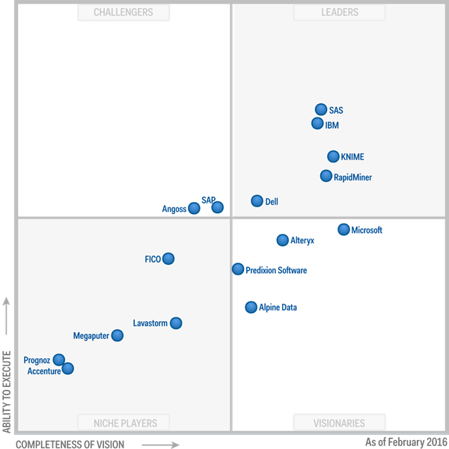

Reference: Gartner-Advanced Analytics & companies (article)

<https://www.cmswire.com/analytics/gartner-rates-these-companies-the-best-in-advanced-analytics/>