Supply Chain Management (Resilient)

Resilient Supply Chain: Manage risk.

Resilient Supply Chain

A supply chain that mitigates risks through

preparing, responding, and recovering

from disruptive supply chain events or threats.

Supply Chain Industry:
 |  | Supply Chain Initiatives
 |  | Lean  (Cost,Waste) | Green  (TBL,CSR) | Resilient  (Risk) | Responsive  (Agile) | Smart  (Technology)
Key Supply Chains | Commodity  Supply Chain
Global
Supply Chain
Service
Supply Chain
Reverse
Supply Chain
 | Functions | Inventory | Logistics | Relationships | Information | Strategy

What is Resilience?
(React, Respond, Recover, Return) from (Known-Known, Known-Unknown, Unknown-Unknown Risks)

What is a Resilient Supply Chain?
(Supply Chain Risk Events vs. Supply Chain Disruptions)

Risk Management

Known-Known Risks | Supply Chain Management
Known-Unknown Risks | Supply Chain Risk Management
Unknown-Unknown Risks | Supply Chain Resiliency Management

Supply Chain Management
Risks | Events | Consequences | Response | Resilience
Known-Known | SRM  ERP  CRM | Quality  Continual  Improvement | SCOR Model | Low  Requirements
Known-Unknown | Market  Economy  Culture | Cost  Service Level | Risk Acceptance  Risk Transference  Risk Mitigation | Moderate  Requirements
Unknown-Unknown | Catastrophes  Uprisings  Subversion | Disruption  Devastation | Redundancy  Sensing & Responding  Adaptability | High  Requirements

How do you develop a Resilient Supply Chain?
(Prepare, Respond, Improve)

Resilient Supply Chain Development
Prepare  (Before) | Respond  (During) | Improve  (After)
Prepare  (Characteristics of  Event Mgt &  Disruption Analysis) | Respond  (Characteristics of  Time: Quick Solutions  Functionality: Complete  Quality: Enhanced) | Improve  (Characteristics of  Internal Culture  &  External Competitiveness)
>Event Management: Risk Analysis  Known-Known Risks  Known-Unknown Risks  Unknown-Unknown Risks  >Disruption Analysis  -Supply Chain Structure  --Redundancy of Systems  --Flexibility of Policies/Processes  --Readiness of Human Resources  -Response Preparation  --Recognition of Events, Patterns, Trends  --Evaluation of Type, Level, Scope  --Mitigation of Probability, Consequences  --Development of Plan | -Communication & Information  -Critical Solution Points  -Identify Minimum Resources  -Delegate Authority to Champions  -Coordinate Solutions  -Transfer Solutions to Strategies

Further Global Supply Chain Resilience Issues
-Security (IT, IP, People)
-Sustainability (Environmental & Sociopolitical)
-Political Coordination and Trust

References

From SupplyChain 24/7.
Article based on authors from Michigan State University.
From SupplyChain24/7: https://www.supplychain247.com/article/understanding_supply_chain_resilience
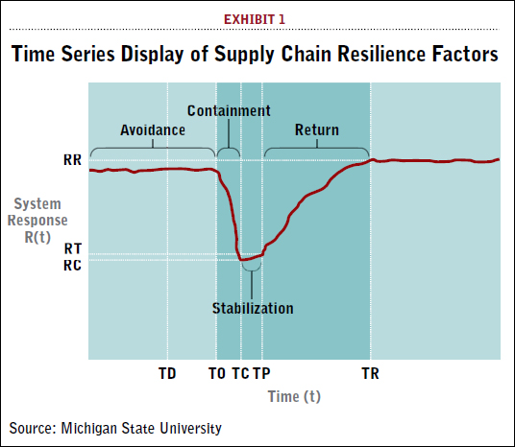 | 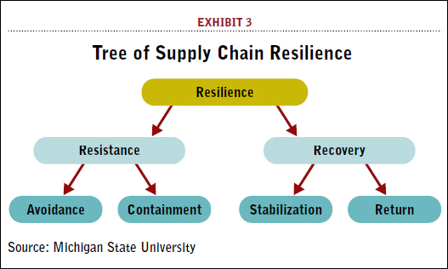

From HBR: Harvard Business Review. By Paul Michelman
https://hbr.org/2007/08/building-a-resilient-supply-ch
Companies can develop resilience in three main ways: increasing redundancy, building flexibility, and changing the corporate culture. The first has limited utility; the others are essential.

From pwc.
Link: https://www.pwc.com/us/en/services/consulting/risk-regulatory/supply-chain-resilience.html
A 2011 article presenting pwc approach to resiliency.
Addressing risks:  1. Anticipate risks  2. Assess risks  3. Act against the risks  4. Designate a business continuity coordinator | Resilient environment:  -Make risk management ongoing  -Develop a partnership approach  -Understand the culture

From Gartner. Link: https://scholar.google.com/scholar?q=gartner%27s+article+on+resilient+supply+chains&hl=en&as_sdt=0&as_vis=1&oi=scholart
Scholarly articles on Resilient Supply Chain Analysis.

From SupplyChain24/7 all 24 papers on supply chain resilience:
https://www.supplychain247.com/search/results/search&category=papers&keywords=Resilience/

