Supply Chain Management – Reverse Supply Chain

Reverse Supply Chains.
When the flow of material is upstream instead of downstream
the supply chain is called a reverse supply chain.
Material can flow upstream because of:
“Returns” which are triggered by downstream agents;
“Recalls” which are initiated by upstream decisions; or
“Recycle” which is a cooperative policy between upstream and downstream parties.

Supply Chain:
Flow of Information
Supplier |  | Manufacturer |  | Distributor |  | Retailer |  | Customer
Flow of Material

Reverse Supply Chain:
Flow of Material
Supplier |  | Manufacturer |  | Distributor |  | Retailer |  | Customer

.

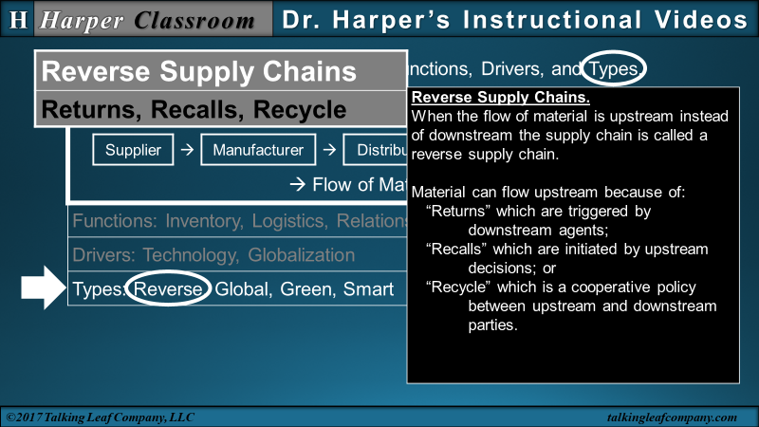

Primary & Secondary Markets
Primary  Market | Supplier |  | Manufacturer |  | Distributor |  | Retailer |  | Customer

Evaluation & Disposition |  | Receive & Document
Reverse
Supply
Chain

 | Disposal  Or Scrap |  | Recycle |  | Remanufacture  Or Refurbish  Or Repair |  | Reuse

Secondary  Market | Supplier |  | Manufacturer |  | Distributor |  | Retailer |  | Customer

.

Reuse | No modification.  Return to Primary or Secondary Market. | Refunds or Exchanges
Repair | Modifications applied.  Return to Secondary Market. | Repair or Maintenance
Recycle | Components, parts or material retrieved.  Provide to Secondary Market or other markets. | Spare parts or Inventory.
Dispose | Destroy, incinerate or scrap.  Eliminate or provide to scrap market. | Landfill.

Customer to Manufacturer
Primary  Market | Supplier |  | Manufacturer |  | Distributor |  | Retailer |  | Customer
 |  |  | ↑ | ← | ← | ← | ← | ← | ↓

Customer to Retailer to Manufacturer
Primary  Market | Supplier |  | Manufacturer |  | Distributor |  | Retailer |  | Customer
 |  |  | ↑ | ← | ← | ← | ↓↑ | ← | ↓

Customer to Third-party to Manufacturer
Primary  Market | Supplier |  | Manufacturer |  | Distributor |  | Retailer |  | Customer
 |  |  | ↑ |  |  |  |  |  | ↓
 |  |  |  | ← | ← | Third-party | ← | ←

Centralized
Cost – Large Inventory – Lean Supply Chain – Postponement – Functional Products
Primary  Market | Supplier |  | Manufacturer |  | Distributor |  | Retailer |  | Customer
Centralized
Evaluation & Disposition |  | Receive & Document
Reverse
Supply
Chain

 | Disposal  Or Scrap |  | Recycle |  | Remanufacture  Or Refurbish  Or Repair |  | Reuse

Secondary  Market | Supplier |  | Manufacturer |  | Distributor |  | Retailer |  | Customer

.

Decentralized

Service – Quick Response – Agile Supply Chain – Early Differentiation – Innovative Products
Primary  Market | Supplier |  | Manufacturer |  | Distributor |  | Retailer |  | Customer
Decentralized

Receive & Document Evaluation & Disposition
Reverse
Supply
Chain

 | Disposal  Or Scrap |  | Recycle |  | Remanufacture  Or Refurbish  Or Repair |  | Reuse

Secondary  Market | Supplier |  | Manufacturer |  | Distributor |  | Retailer |  | Customer

.

Strategic Reverse Supply Chain Management
Opportunities | Barriers
Increased Customer Satisfaction  Secondary Markets  Enhanced Information  Sustainability | Brand Erosion  Logistics Costs & Low Profit Margins  Coordination & Top Management Commitment  Minimal Legal Issues

Green  Reverse Supply Chain  Management | Lean  Reverse Supply Chain  Management | Agile  Reverse Supply Chain  Management

