Supply Chain Management – Resilient Supply Chain

What is Resilience?
(Return, Recover, Respond, React)

What is a Resilient Supply Chain?
(Supply Chain Risk Events vs. Supply Chain Disruptions)

How do you develop a Resilient Supply Chain?
(Prepare, Respond, Improve)

Resilient Supply Chain Development
Prepare  (Before) | Respond  (During) | Improve  (After)
Prepare  (Characteristics of  Event Management &  Disruption Analysis) | Respond  (Characteristics of  Time: Quick Solutions  Functionality: Complete  Quality: Enhanced) | Improve  (Characteristics of  Internal Culture  &  External Competitiveness)
>Event Management: Risk Analysis  Known-Known Risks  Known-Unknown Risks  Unknown-Unknown Risks  >Disruption Analysis  -Supply Chain Structure  --Redundancy of Systems  --Flexibility of Policies/Processes  --Readiness of Human Resources  -Response Preparation  --Recognition of Events, Patterns, Trends  --Evaluation of Type, Level, Scope  --Mitigation of Probability, Consequences  --Development of Plan | -Communication & Information  -Critical Solution Points  -Identify Minimum Resources  -Delegate Authority to Champions  -Coordinate Solutions  -Transfer Solutions to Strategies

Further Global Supply Chain Resilience Issues
-Security (IT, IP, People)
-Sustainability (Environmental & Sociopolitical)
-Political Coordination and Trust

Risk Management

Known-Known Risks | Supply Chain Management
Known-Unknown Risks | Supply Chain Risk Management
Unknown-Unknown Risks | Supply Chain Resilience Management

(Knowledge of the Risk-Knowledge of the Outcome)

Supply Chain Management
Risks | Events | Consequences | Response | Resilience
Known-Known | SRM  ERP  CRM | Quality  Continual  Improvement | SCOR Model | Low  Requirements
Known-Unknown | Market  Economy  Culture | Cost  Service Level | Risk Acceptance  Risk Transference  Risk Mitigation | Moderate  Requirements
Unknown-Unknown | Catastrophes  Uprisings  Subversion | Disruption  Devastation | Redundancy  Sensing & Responding  Adaptability | High  Requirements

References

From SupplyChain 24/7.
Article based on authors from Michigan State University.

From SupplyChain24/7: https://www.supplychain247.com/article/understanding_supply_chain_resilience

Considers Resilience consisting of Resistance and Recovery.
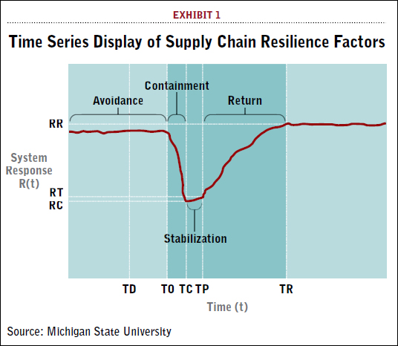
Tree of Supply Chain Resilience



